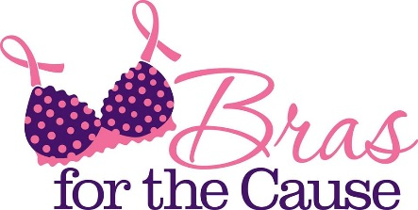
Bras for the Cause
1551 Valley West Drive, #208
West Des Moines, IA 50266
515.226.2388
www.BrasForTheCause.com

Design a Bra for the 2020 Bras for the Cause Gala!
Submissions are due to the Bra Committee by September 7th
This form should be filled out and submitted along with the Bra

Contact Name (First and Last):
Other Designers (if applicable):
Organization (if applicable):
Phone number, email and address will only be used to contact you with questions regarding the bra submitted or providing information regarding Bras for the Cause events. We do not share volunteer or donor contact information.
Phone: Fax: Cell:
Email:
Address:
City: State: Zip Code:

Bra Artwork Information
Title of Bra:
Artist(s) and/or Organization names as it should appear in the Gala Catalog and on display tag:
Name 1: Name 3:
Name 2: Name 4:
Do you need a donation form for tax purposes?
Does this Bra have an auction basket/item it should be specifically paired with?
If so, a brief description of auction item:
(Please check with your tax advisor for deductions)
Option Information:
Are you a cancer survivor? Yes No
Bra submitted in honor/memory/support (circle one) of:
Others whom you would like to acknowledge:
I understand I am donating this bra to Bras for the Cause and relinquish and rights/monies to this bra.

Signature: Date:
Additional Information to be displayed with Bra (Optional):

