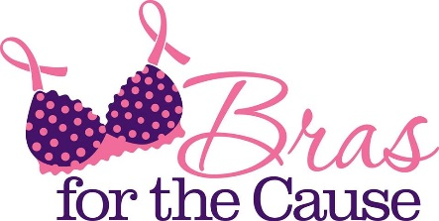
Bras for the Cause
1551 Valley West Drive, #208
West Des Moines, IA 50266
515.226.2388
www.BrasForTheCause.com

Donate to the 2020 Bras for the Cause Gala!
This form should be filled out and submitted along with the Auction Item(s)

Contact Name (First and Last):
Organization (if applicable):
Phone number, email and address will only be used to contact you with questions regarding the bra submitted or providing information regarding Bras for the Cause events. We do not share volunteer or donor contact information.
Phone: Fax: Cell:
Email:
Address:
City: State: Zip Code:

Donation Information
Cash Donation: $
(e.g. money toward Bras for the Cause)
Auction Item:
Approximate Total Value: $
Description (If multiple items, please itemize on 2nd page):
Gift in Kind (Approximately Value): $
Description:
(e.g. goods or services to use for Gala Event, Gallery of Bras, etc.)
In Memory/Honor/Support of (optional)
Does this donation have a Bra Submission to be paired with for the Auction?
If yes, provide name of Bra Submission:
Would you like a receipt?

Contact Signature: Date:

Itemization of Auction Items (please provide item description and approximate value of each item):

$ $ $ $ $ $ $ $ $ $ $ $ $ $ $ $ $ $ $ $ $ $ $ $

